EC-341 Digital System Design
BS (CE)-2021
LAB REPORT # 12

Submitted By:
Reg. No. | Name
21-CE-009 | Huzaifa Shahbaz
21-CE-020 | Muhammad Ibthesam
21-CE-021 | Yawar Ali Malik

Department of Computer Engineering
HITEC University Taxila
 | Presentation  (Format(0.5)+Title (0.5)+  Conclusion(1)+Procedure(2)+Objective(1)) | Calculation/Coding | Observation/ Program Results | Total
Total | 5 | 5 | 5 | 15
Obtained

___________________________
Lab Instructor.
Fasih Ahmad
Experiment #12
Implementation of Moore State Machine
Objective: To develop the source code for Moore machine by using VERILOG and obtain the simulation and synthesis.

Equipment/Software Used: Xilinx Vivado

Procedure: A state machine is an abstract way of describing the behavior of a controller. The state machine description reduces the description of any controller to just four things: inputs, outputs, states, and state transition rules. The state machine description contains no details about the implementation of the controller (no flowcharts, programs, schematics, mechanical diagrams, etc.). Instead, a state machine only describes the different states that the controller can be in, the outputs in each state, and what input conditions will cause transitions between states. A state machine description can be used to describe and analyze existing systems and to aid in the design of new systems. The simplified description represented by a state machine allows us to verify proper operation and document the logical operation of a controller before proceeding with detailed design (e.g. writing a program or designing hardware). Design of State Machine: There are four steps to designing a state machine: 1.Define the outputs – these are the output signals used by the controller 2.Define the inputs – the input signals provided to the controller 3.Define all of the possible states that the controller will need to be in and what values the outputs will take for each of these states 4.Define the exact input conditions that will cause the state machine to switch from one state to another.
Tasks
Task #1(i): A Moore machine is a finite state machine where the outputs are determined by the current state alone (and do not depend directly on the input). The state diagram for a Moore machine will include an output signal for each state, compared with a Mealy machine, which maps transitions in the machine to outputs. The advantage of the Moore model is a simplification of the behavior. BLOCK DIAGRAM: 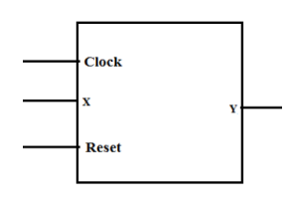
Truth Table: 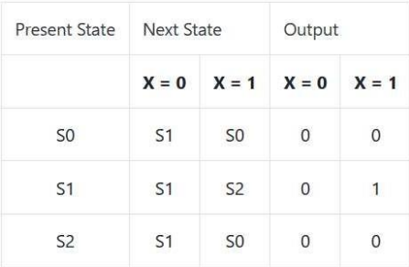
State diagram: 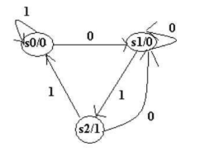
Verliog: module moore(
input x,
input clock;
input reset;
output reg y
);
reg [1:0] Next_state;
parameter s0=2'b00,s1==2'b01,s2=2'b10;
always @(posedge clock)
begin
if (reset)
begin
Next_state=s0;
y=1'b0;
end
case(Next_state)
s0:begin
y=1'b0;
if(x)
Next_state=s0;
else:
Next_state=s1;
end
s1:begin
y=1'b0;
if(x)
Next_state=s2;
else
Next_sate=s1;
end
s2:begin
y=1'b1;
if(x)
Next_state=s0;
else
Next_State=s1;
end
endcase
end
endmodule module testbench();
reg x;
reg clock;
reg reset;
wire y;
moore uut(.y(y),.x(x),.clock(clock),.reset(reset));
initial
begin
x=0;clock=10;reset=1;
#10 x=0;reset=0;
#10 x=1;
#10 x=0;
#10 x=1;
#10 x=0;
#10 x=1;
#100;
end
endmodule
Waveform: 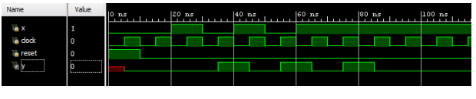
Task #1(ii): Design a controller for a system that actuates on the input provided by a 1-bit sensor. The system actuates (gives O/P as 1) when it detects two consecutive ones followed by a zero which are then followed by two consecutive ones. State diagram: 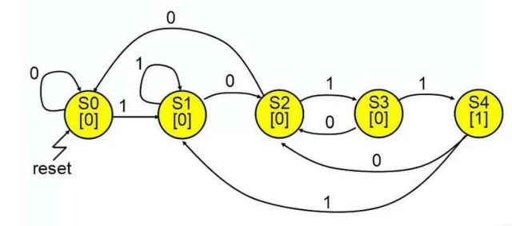 Truth Table: 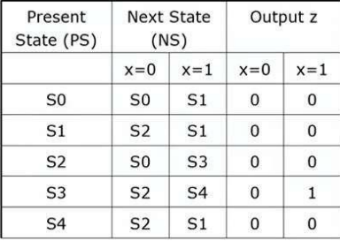
Verliog: 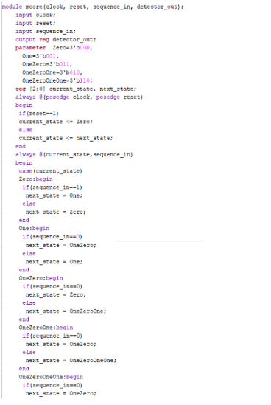 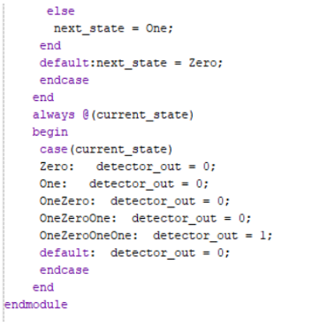
Waveform: 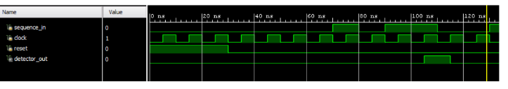
Conclusion (write 1 to 2 lines conclusion of experiment you performed in Times New Roman 12)

